AFHEA Queen’s Merit Award Registration Form

Welcome to the Professional Recognition Scheme at Queen’s University Belfast leading to Fellowship of the Higher Education Academy (HEA). Your Line Manager, Head of School or PhD Supervisor (if applicable) should be cc’d and submitted to qma@qub.ac.uk. The process is supported by a Canvas course.

In order to express your interest to apply for QMA, please send this completed form to the email address qma@qub.ac.uk

The purpose of this form is to allow you to provide a brief overview of your higher education career and your teaching and/or supporting learning roles and responsibilities to date. Before you submit this registration form you should complete the Advance HE decision tool, to ensure you are aiming for the right category of Fellowship for you.
You may also wish to talk to your Line Manager, Head of School or PhD Supervisor to gain advice and/or contact the QMA Programme Lead if you have any questions.
QMA Programme Lead: Karen Fraser (qma@qub.ac.uk), 5865
QMA Administrator: Julio Carreño (qma@qub.ac.uk), 5845

Section A – Personal and Factual Details

Personal Details
Title
First Name
Surname
Job role
Contact email
School/Department/Institute
Line Manager, Head of School or PhD Supervisor |  | (enter details if applicable)
Mentors Name
Intended Submission Date for Application

Please indicate here which month and year you are intending to submit your application
Please indicate what format you will submit your application in
Please tick one
Written |  |  | Recorded Presentation

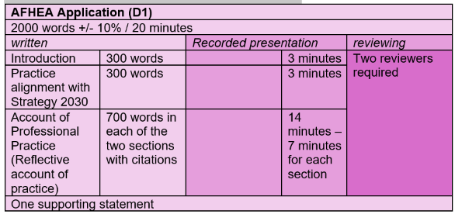

Section B – Teaching and/or Supporting Learning Roles and Responsibilities

In this section please briefly outline your principal teaching and/or supporting learning roles and responsibilities within your current job role at Queen’s, and then more broadly over the last 3 years (if applicable). Roles and responsibilities listed need to be relevant to the category of fellowship you are applying for.
Current Teaching and/or Supporting Learning Roles and Responsibilities at Queen’s in the last two years | From | To

Section C – Referees and Advocates – this cannot be your mentor

Please provide the name of your referee for Associate Fellow, (download the Guidance for applicants on the QMA Website for advice on choosing referees/advocates and other details specific to each fellowship category).

Referee /Advocate
Name
Fellowship level
Job Position
Email

Section D – Sign and Date

Please complete, sign and date your registration form and forward it to your Line Manager, Head of School or PhD Supervisor for endorsing and signing. We can also accept signatures drawn electronically. We can also accept the application sent via email with no signatures as long as the relevant Line Manager/Head of School/PhD Supervisor has been copied in. Please send your completed form to qma@qub.ac.uk; you will receive notice of its receipt. Once you are registered for the QMA, you will be sent an email inviting you to sign up for an induction workshop and providing further instructions.
Date:

Signed by Applicant:

Line Manager/Head of School/PhD Supervisor cc’d.

